Home SOC Lab Using Wazuh

Project Overview
This project demonstrates the creation of a Home Security Operations Center (SOC) Lab using Wazuh for centralized log collection, monitoring, and security event detection.
The lab consists of a Wazuh SIEM server, Windows endpoint, and Linux endpoint running in VirtualBox. The objective was to gain hands-on experience with log monitoring, threat detection, and incident investigation.

Lab Architecture

Components
Component | Purpose
Wazuh OVA | SIEM Platform
Windows 11 | Endpoint Monitoring
Xubuntu | Linux Endpoint
VirtualBox | Virtualization Platform
Threat Intelligence Source | VirusTotal API

Architecture Diagram
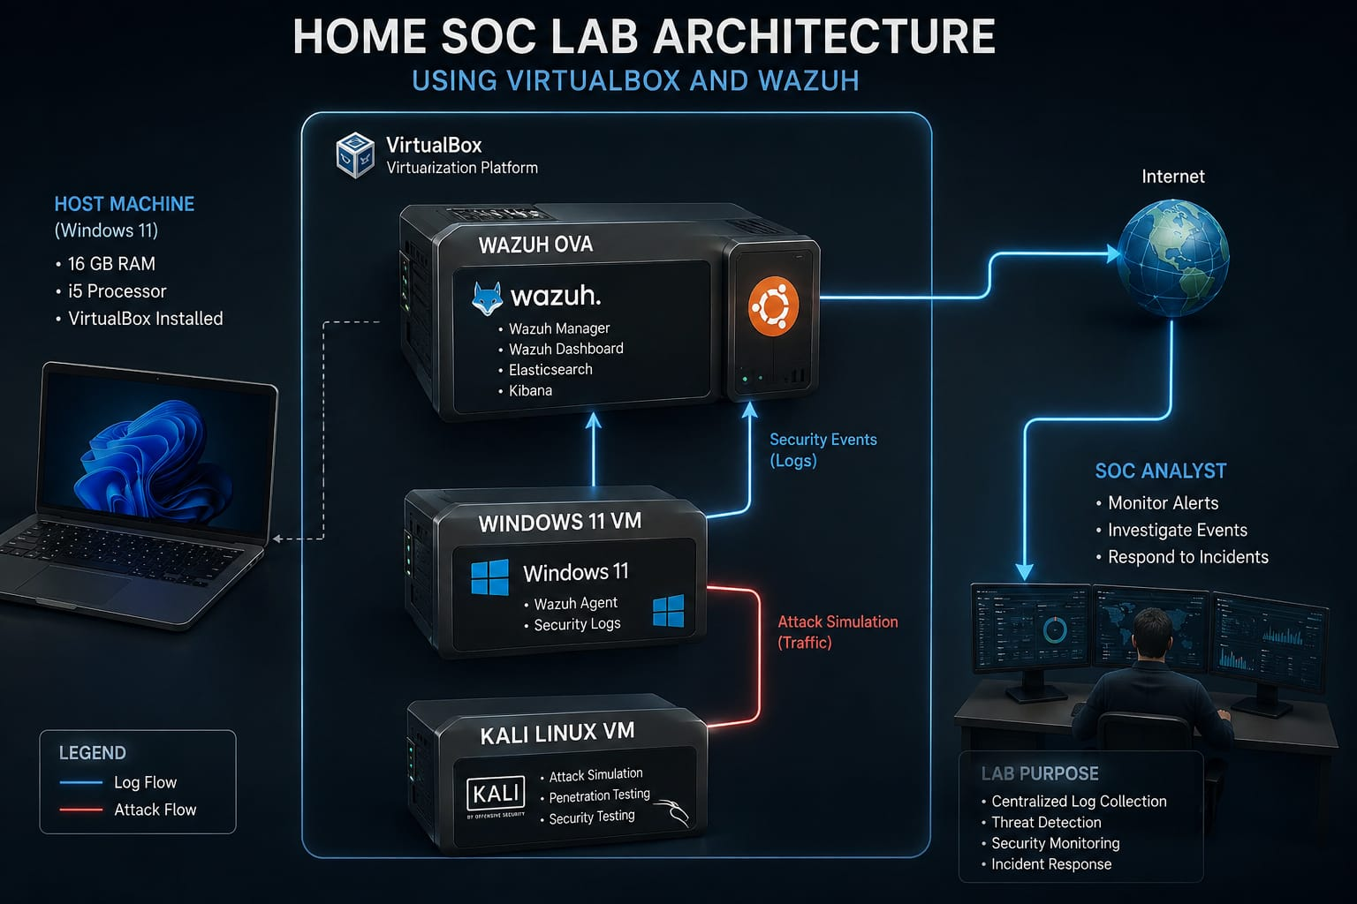

Environment Setup

Host System
- Windows 11
- 16 GB RAM
- VirtualBox

Virtual Machines

Wazuh Server
- Imported using Wazuh OVA
- Used as centralized SIEM platform

Windows Endpoint
- Connected to Wazuh Manager
- Registered as a Wazuh Agent

Xubuntu Endpoint
- Installed for Linux monitoring and testing

Agent Enrollment
The Windows endpoint was successfully enrolled into the Wazuh Manager.

Verification
The agent appeared online within the Wazuh Dashboard.
Evidence
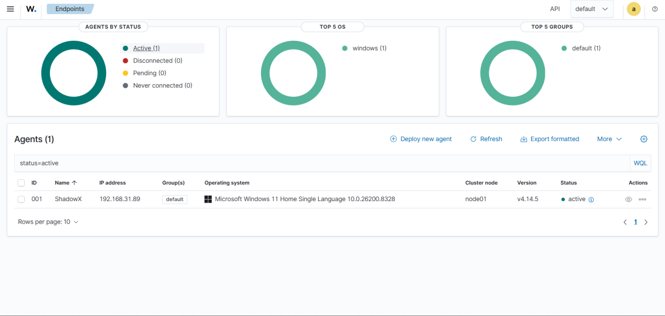

Security Event Simulation
To test the monitoring capabilities of Wazuh, multiple security-related activities were performed.

Use Case 1: Failed Login Attempts

Objective
Verify whether Wazuh detects authentication failures.

Activity Performed
The Windows system was intentionally locked.
Multiple login attempts were made using incorrect passwords.

Detection
Wazuh generated authentication failure events.

Evidence
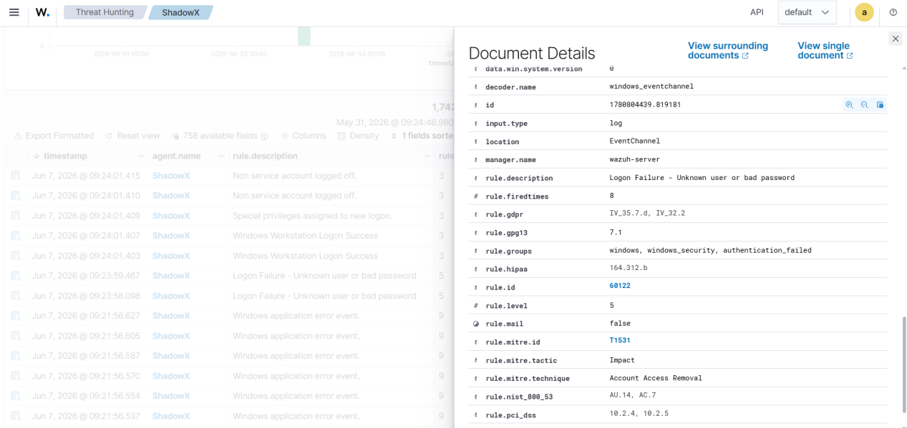

Result
Authentication monitoring was successfully validated.

Use Case 2: User Account Creation

Objective
Verify account management monitoring.

Activity Performed
A new local user account was created.
net user testuser Password123! /add

Detection
Wazuh detected account creation activity.

Evidence

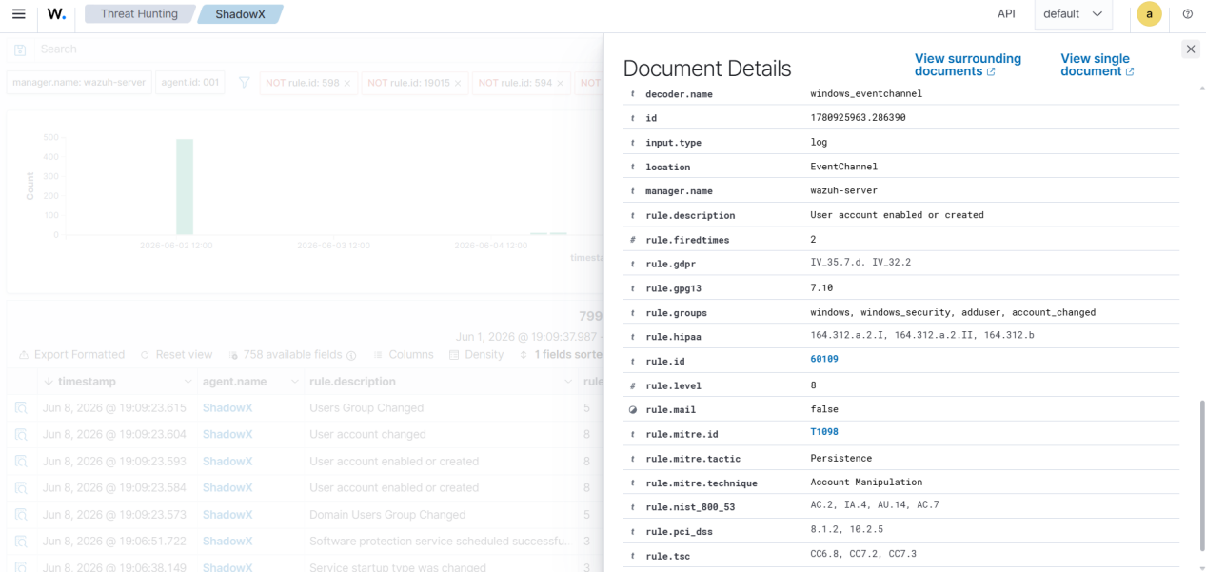Result
User account creation was successfully logged.

Use Case 3: User Account Deletion

Objective
Verify account deletion monitoring.

Activity Performed
A previously created user account was deleted.
net user testuser /delete

Detection
Wazuh recorded the account deletion event.

Evidence

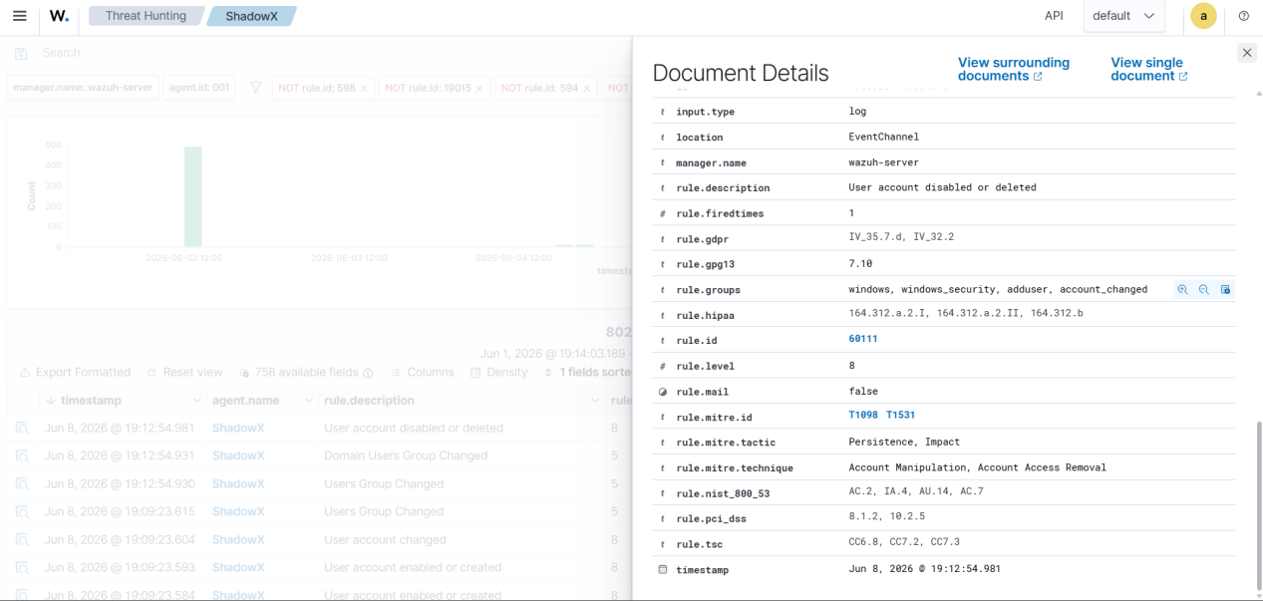Result
Account lifecycle monitoring was successfully validated.

API Configuration
VirusTotal integration was configured within the Wazuh Manager by modifying the ossec.conf file.
<integration>
<name>virustotal</name>
<api_key>REDACTED</api_key>
<group>syscheck</group>
<alert_format>json</alert_format>
</integration>
For security reasons, the API key has been omitted from the documentation.

File Integrity Monitoring Configuration
A dedicated monitoring folder was created on the Windows endpoint:
C:\SOC-Test
The following configuration was added to the Wazuh Agent:
<directories realtime="yes">
C:\SOC-Test
</directories>
This enabled real-time monitoring of file activities within the directory.

Test Procedure
A test file was created within the monitored directory.
C:\SOC-Test\test.txt
The file was subsequently deleted to verify whether Wazuh could detect file lifecycle events.
Evidence
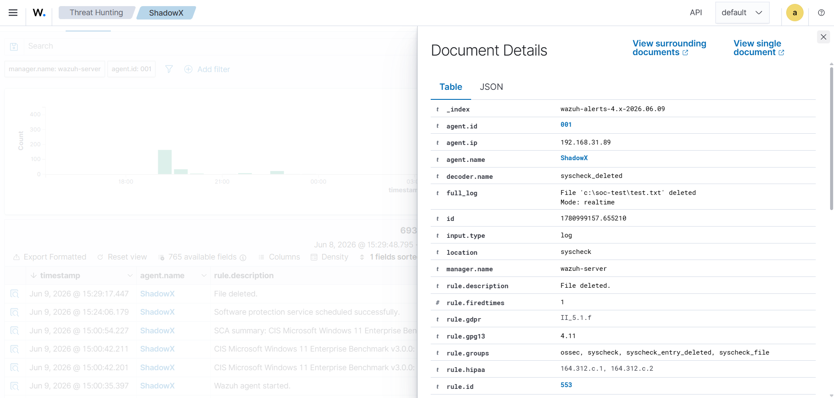

Findings
The Home SOC Lab successfully demonstrated:
- Centralized log collection
- Endpoint monitoring
- Authentication monitoring
- User account auditing
- Security alert generation
- File Integrity monitoring
Wazuh successfully detected all simulated security events and provided visibility into endpoint activities.

Challenges Encountered
- Agent connectivity troubleshooting
- VirtualBox network configuration
- Initial log collection verification
These issues were resolved by validating network connectivity and agent configuration.

Lessons Learned
Through this project I learned:
- How SIEM solutions collect logs
- How Wazuh agents communicate with the manager
- Windows security event monitoring
- Basic incident investigation workflows
- Security event correlation

